Biography: Hon Steve Maharey CNZM, B.A., M.A (Hons)

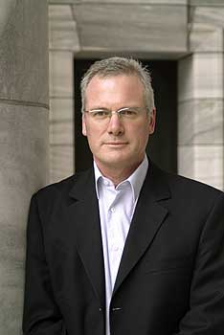
Steve Maharey is the Vice-Chancellor of Massey University. Prior to this he was the fourth ranked Minister in Government for nine years holding the positions of Minister of Education, Minister Responsible for the Education Review Office and the New Zealand Qualifications Authority, Minister of Research, Science and Technology, Minister Responsible for Crown Research Institutes, Minister of Broadcasting, Minister Responsible for Television New Zealand, Chair of the Cabinet Social Development Committee and Member of Parliament for Palmerston North for eighteen years from 1990 until 2008.
In Government he was also Minister of Social Development and Employment, Minister of Child, Youth and Family, Associate Minister of Education (Responsible for Tertiary Education), Minister of Housing, Minister for the Community and Voluntary Sector, Minister of Youth Affairs. He had responsibility for the Families Commission, Learning Media, the Foundation for Research Science and Technology, Marsden Fund, the Health Funding Authority and many other public agencies.
In Opposition he was a front bench Spokesperson on Education, Employment, Broadcasting, Communications, Labour Relations, Social Welfare and Employment as well being a member of the Education and Science, Labour, Commerce, Broadcasting, Standing Orders and Social Welfare and Employment Select Committees.
Prior to entering Parliament he was a Snr Lecturer in Sociology. Earlier in his career he was a Jnr. Lecturer in Business Administration. He was influential, through his teaching and publications, in the development of New Zealand sociology and formation of the fields of cultural studies and media studies in New Zealand. His academic interests include social policy (particularly social development), education, media and cultural studies, social change and politics.
He is currently working on the public domain and its importance in the 21st century.
He has served as an elected City Councillor.
He is currently on the Board of the Wellington Employers Chamber of Commerce, the Committee for Auckland, the Territorial Force Employers Support Council, and the Board of the Manawatu Cancer Society. He is Patron of the Australasian Tertiary Education Managers Association and the Manawatu Squash Association.
He was appointed a Companion of the New Zealand Order of Merit (CNZM) in 2008.
He has extensive experience in all forms of media. He is a frequently invited speaker and contributor to the media.

